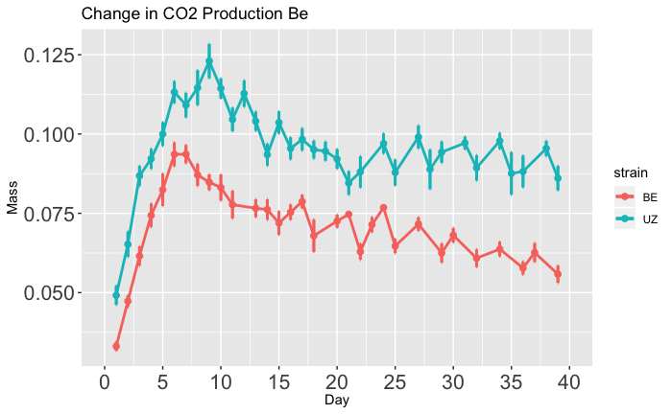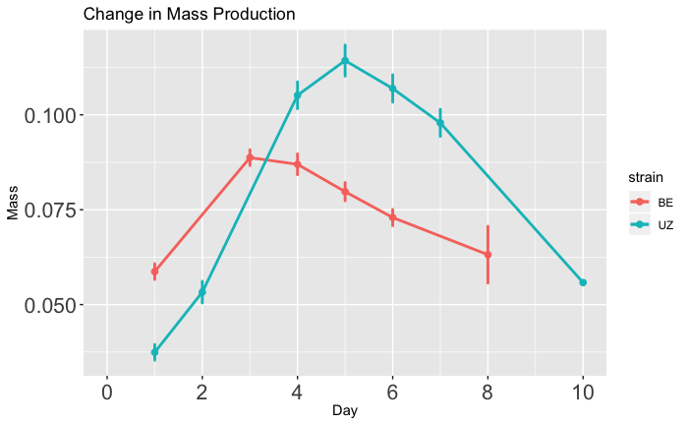

0.100

0.075

0.500

0 2 4 6 8 10

Time (days)

0.125

0.100

0.075

0.050

0 5 10 15 20 25 30 35 40

Time (days)

Wet Mass (g)

(Non-diapause)

Wet Mass (g)

(Diapause)

B

Long-Diapause

Short-Diapause

Long-Diapause

Short-Diapause

A